HOLY CROSS CONVENT SENIOR SECONDARY SCHOOL,AMBIKAPUR

CLASS - IV
SUBJECT - ENGLISH GRAMMAR

Note: Students are instructed to write the following notes in their English grammar book with pencil.
Students not having the book can practice it in their English practice copy.

- WHAT THEY DO FOR US ?

Shopkeeper | Carpenter | Teacher | Iron smith | Baker | Driver
Doctor | Electrician | Plumber | Postman | Policeman | Fireman

 | 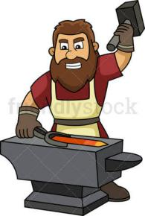 |  | 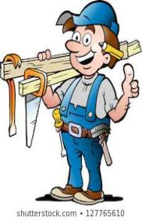 |  | 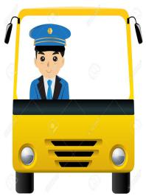
 | 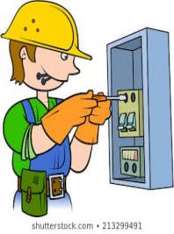 | 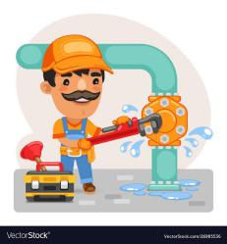 |  | 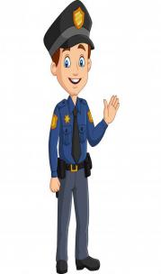 | 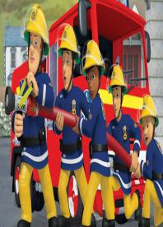

WORKSHEET

- Read each word-group and write the correct word against it:

- A person who sells bread and biscuits. : baker
- A person who makes furniture. : carpenter
- A person who makes articles of iron. : iron smith
- A person who drives a vehicle. : driver
- A person who runs a shop. : shopkeeper
- A person who does electric jobs. : electrician
- A person who repairs taps and pipes. : plumber
- A person who brings us our mail. : postman
- A person who keeps eye on bad characters. : policeman
- A person who puts out fire in fire - accidents : fireman
- A person who cures us when we are unwell. :doctor
- A person who teaches in school. :teacher

